**eClassroom: Classroom Management System**

**Introduction:**

eClassroom is a modern classroom management system designed to streamline the interaction between teachers and students in a virtual classroom environment. Built on the MERN stack (MongoDB, Express.js, React.js, Node.js), eClassroom offers a user-friendly interface for teachers to create classrooms, post updates, upload documents, and manage student interactions. Students can join classrooms, view posts, and engage with their peers and instructors through replies and discussions.

**User Roles:**

* Student
* Teacher

**Features:**

* *Classroom Creation:*

Teachers can create virtual classrooms for different courses or subjects.Option to customize classroom details including name, description, and access settings.

* *Post Creation and Management:*

Teachers can create posts to share announcements, assignments, or resources with students.Ability to attach documents, links, or multimedia files to posts.Edit and delete posts as needed.

* *Media Upload:*

Teachers can upload documents such as lecture slides, images reading materials, or assignment guidelines. Support for various file formats including PDF, DOCX, PPTX, etc.

* *Student Enrollment:*

Students can easily join classrooms by searching for the desired course or entering educator name and classroom code provided by the instructor.

* *Post Viewing and Interaction:*

Students can view posts posted by teachers in their respective classrooms. Option to give replies, ask questions, or engage in discussions related to the post topic.

**Flow Diagram**

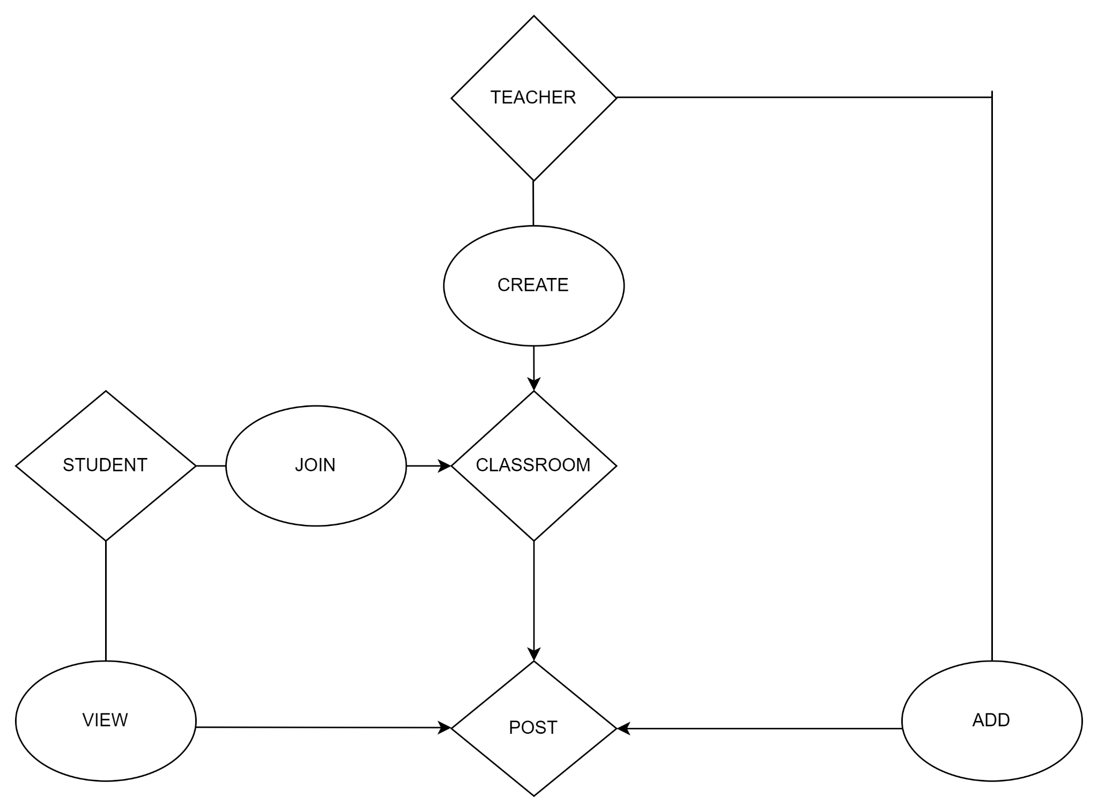

**Technology Stack:**

* **Frontend**: React.js(in NEXT JS)
* **Backend**: Express.js
* **Database**: MongoDB
* **API Development**: Node.js
* **Cloud Storage:** Cloudinary
* **Libraries:** bcryptjs, mongoose

**Security:**

* **Password Storage**: User passwords will be stored in encrypted form using a strong hashing algorithm, such as bcrypt, to prevent unauthorized access to plaintext passwords.
* **JWT Tokens**: JSON Web Tokens (JWT) will be used for user authentication. JWTs are secure, self-contained, and digitally signed, providing a secure method for user authentication and authorization.

**Databases:**

1. **Users:** Contains users email id,password(in encrypted form),role
2. **Educators:** Contains educator name, classrooms
3. **Students:** Contains student name, classrooms
4. **Classrooms:** Contains classroom code,educator name, students enrolled, subject, group , posts of classroom
5. **Posts:** Contains posts, classroom of post, replies of posts

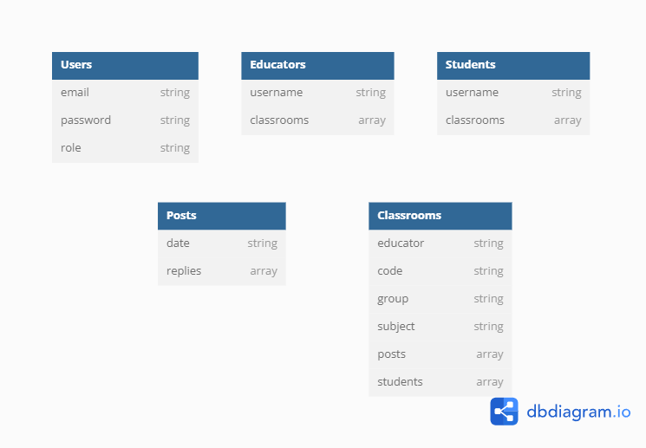

**Ports**

The frontend is running on port 3000, while the backend is running on port 8000. These two components are connected through Cross-Origin Resource Sharing (CORS).

**Deployment:**

It will be deployed on Vercel

l

**Future Enhancements:**

* Integration of real-time messaging or video conferencing for live interactions between teachers and students.
* Implementation of grading and assessment features for evaluating student performance.
* Analytics dashboard for monitoring classroom engagement and performance metrics.

**Conclusion:**

eClassroom revolutionizes the way faculty manages virtual classrooms, offering a robust platform for effective communication and collaboration between teachers and students. With its modern features and user-friendly interface, eClassroom aims to enhance the online learning experience for all users.